**ASSIGNMENT-1**

**PICTURE OF ME:**

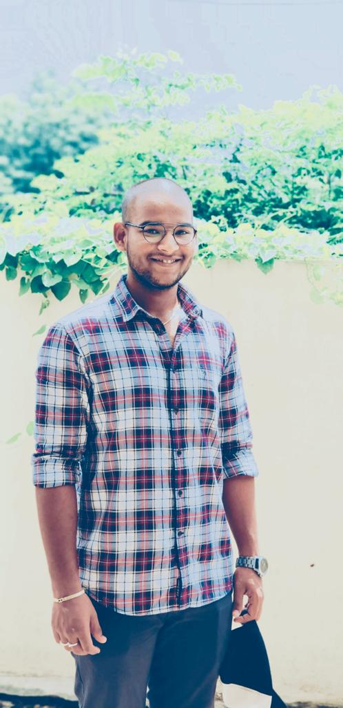

**ABOUT ME:**

I am a person who knows about computer around 40-50% which includes the details of web programming and shows a small term of coding language of C, Java. My undergraduate major is Computer Science which includes basic project designing and short-term coding. I involved in project like “Student Data Base Management System”, Hospital Management System”.

**AFTER THIS COURSE:**

I am expecting me with full knowledge of designing a website myself and I think I will be able to achieve my goals which involves highly paid jobs as “Full Stack developer” and “Sever administrators.”

**CONCLUSION:**

I am very thankful to you professor for giving me such opportunity to elaborate myself, and I am looking forward to meeting you in person and learn some important skills to sustain and conquer the “Realtime Software World.”